Western Union Rec JOB AID
Description | Balancing Western Union Demand Accounts: 101007999284; 101008000167
Target audience | Centralized Services - Reconciliations
Prerequisites | T24, GlobalPay (WUBS), busienssonlinewires group email access
Date published

Policy statements
- Centralized Services Manual- Centralized Services is responsible for balancing Western Union’s Demand accounts to the Western Union Settlement and CWB’s clients.

Steps
Step | Instruction
1 | Open Western Union Reconciliation  CAD: \\cwb.local\shared\Corp\CAP\Reconciliations\Western Union\WU_Reconciliation_CAD.xlsx  USD: \\cwb.local\shared\Corp\CAP\Reconciliations\Western Union\WU_Reconciliation_USD.xlsx
2 | Pull the account transactions and balanced of the Western Union Demand Accounts 101007999284 & 101008000167 for rec date from T24  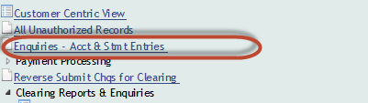  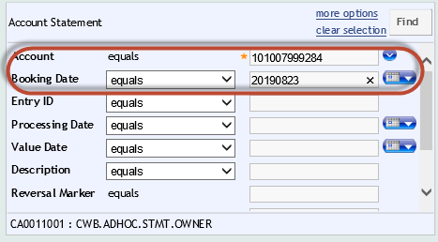
3 | Export the enquiry to csv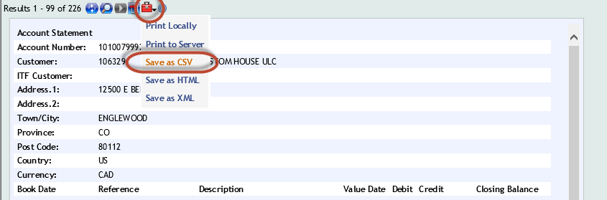
4 | Run T24 Statement Macro from Excel Ribbon and Print the report.  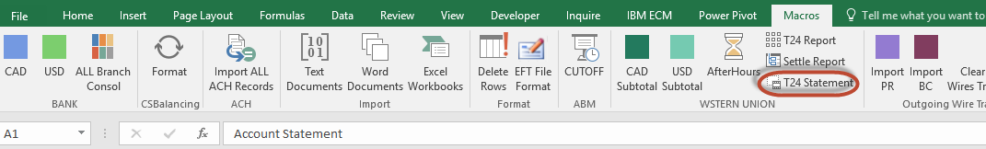
5 | Pull Managed Pricing Report from WUBS. These reports are sent to email inbox: businessonlinewires@cwbank.com. Double click the Secure Message attachment  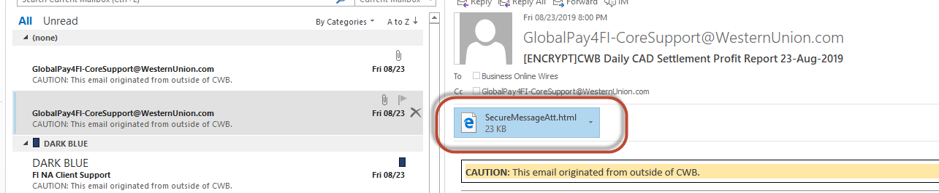  Manual Steps:
6 | Select to Open the file  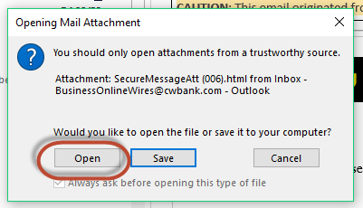
7 | Select Click to read message  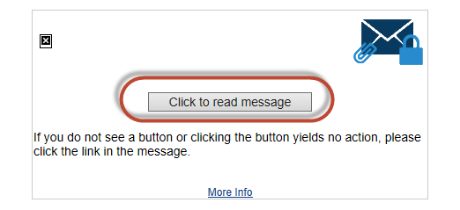
8 | A login will be required to access the files. The password = We$tern1  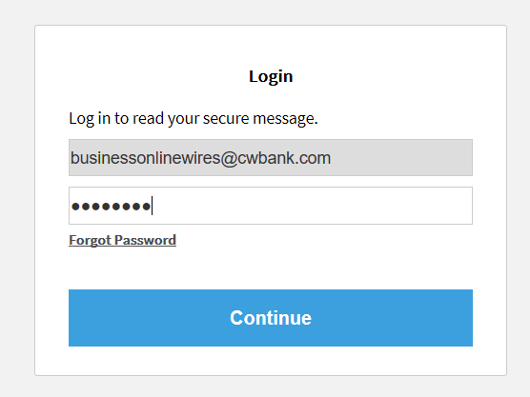
9 | Open the attachment and run the AfterHours Macro on the Excel Ribbon. Print the Report.  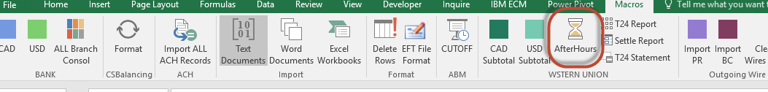
10 | Open the settlement recs done the day before and print the Held Payments report.  \\cwb.local\shared\Corp\CAP\Reconciliations\Western Union\WU_Settlement_CAD.xlsx  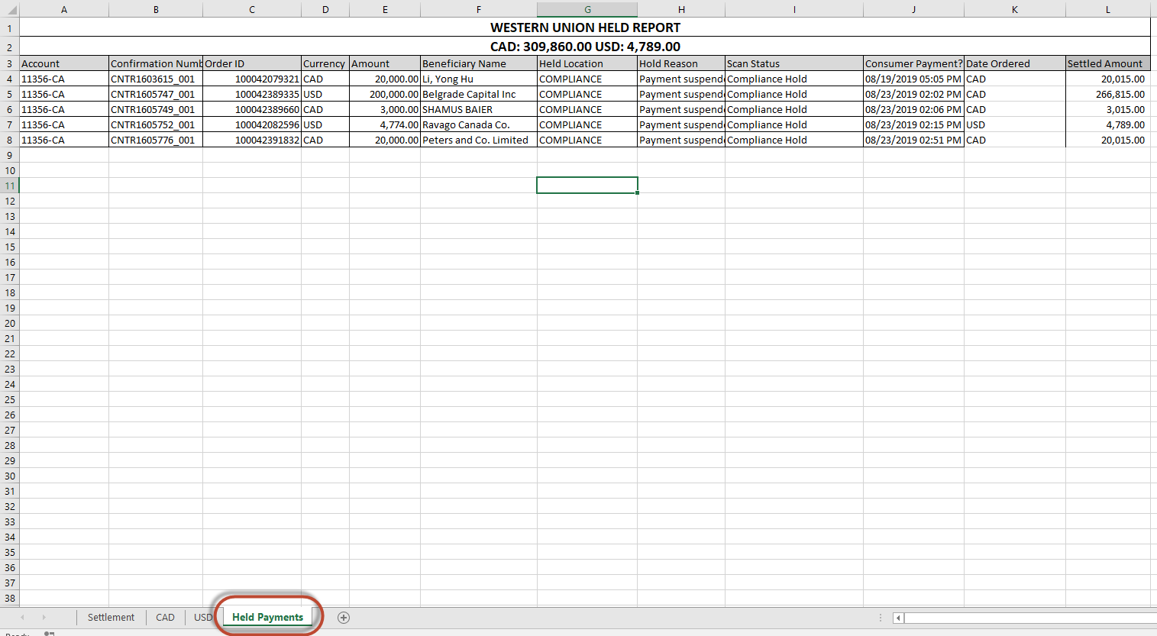
10 | In the reconciliation, Enter in the rec date.  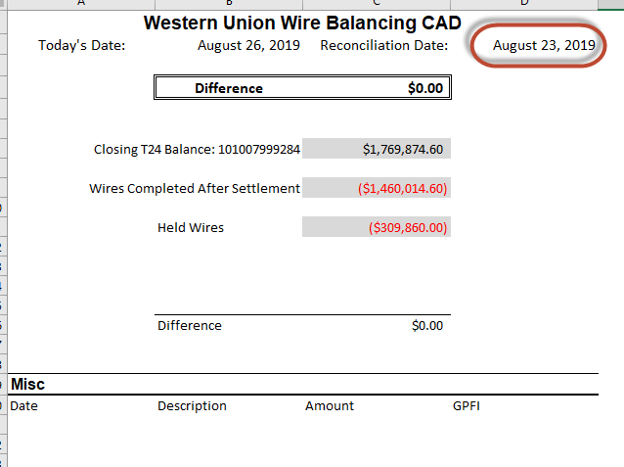
11 | Enter In the closing balance from the account statement.  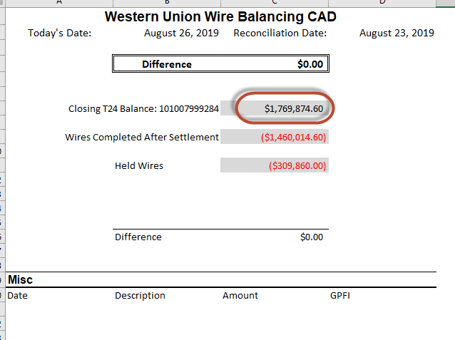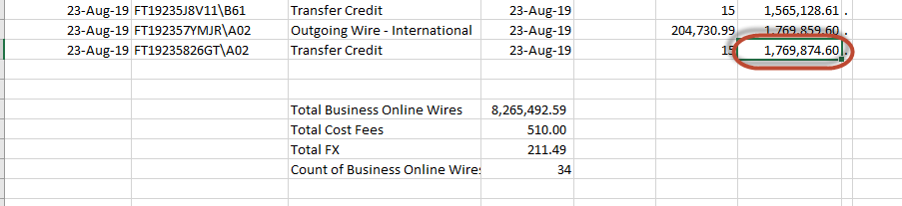
12 | Enter in the Wires Completed after settlement from the Managed Pricing Report.  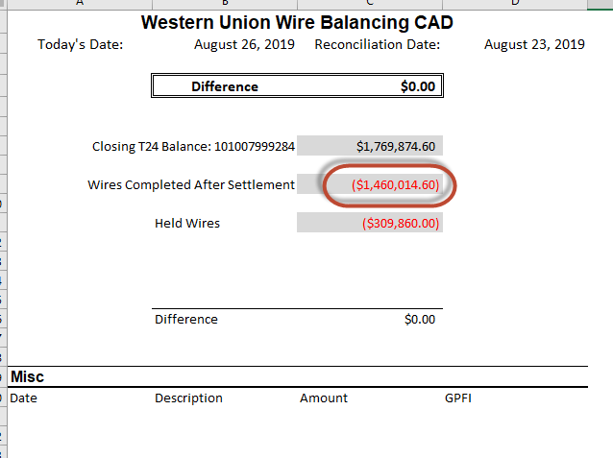  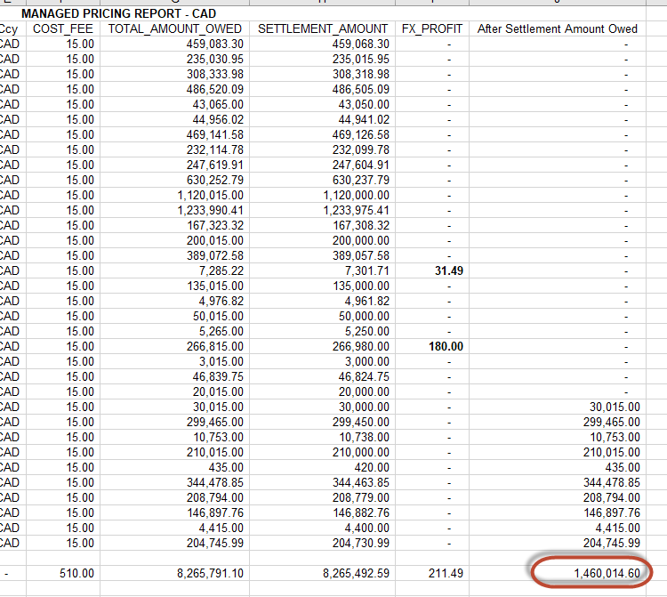
13 | Enter in the Held Wires from the settlement rec done the day before.  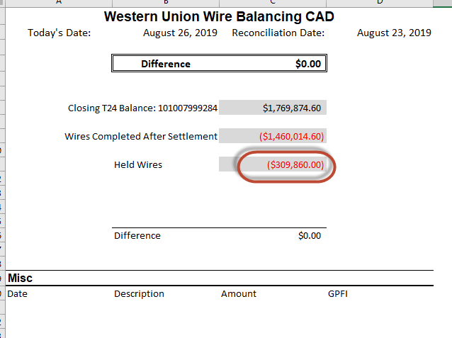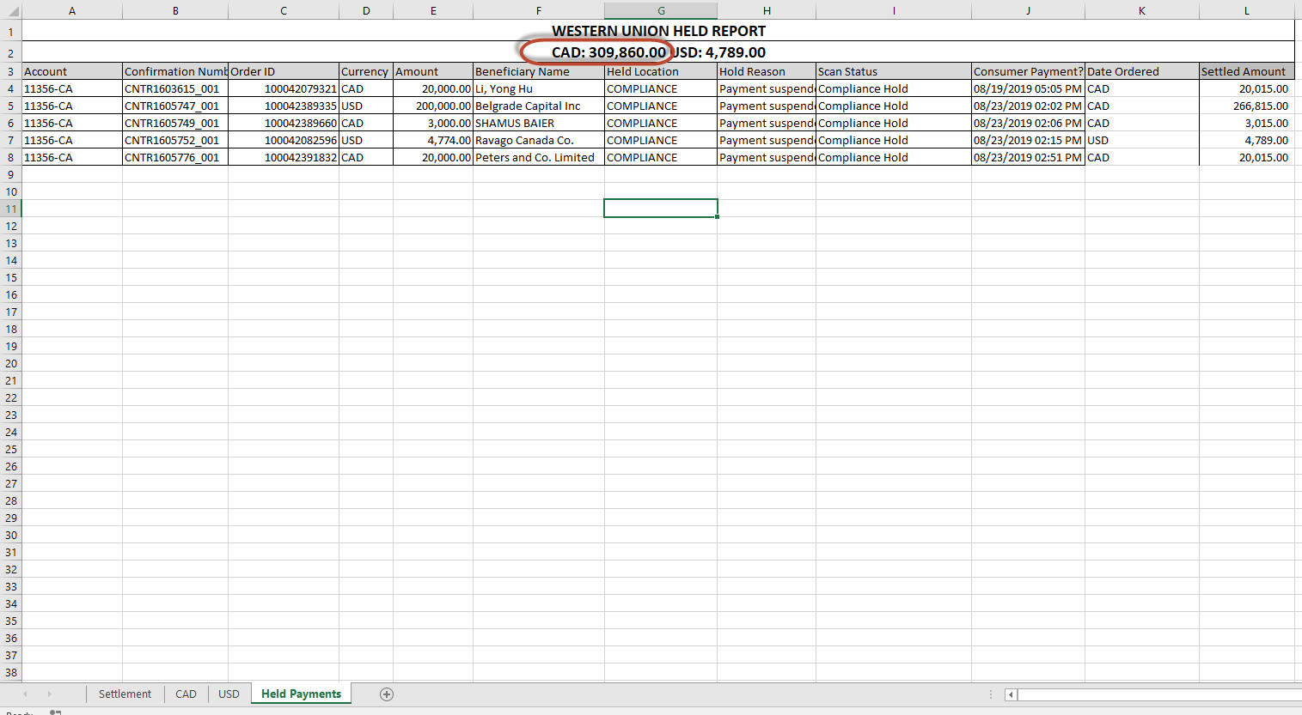
14 | Enter in any Misc item. Examples are:  Wire payments not posted, Cancelled Wires not posted, USD account fees.  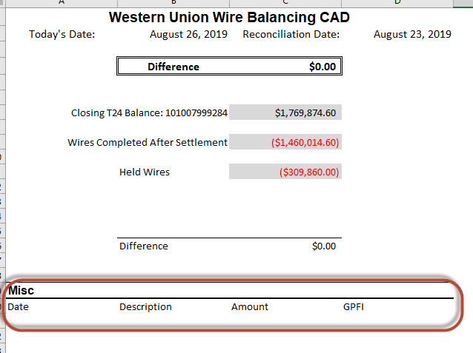
15 | The difference should now be at $0.00. If it is not, investigate or reach out to management for further assistance.
16 | Save a copy of the rec under the recs backup folder:  \\cwb.local\shared\Corp\CAP\Reconciliations\Western Union\Recs\
17 | Print Reconciliation, T24, WU spreadsheets. Put reconciliation paperwork in order and hand in for checking.

